QR Hunt

Business Case

Written by Gordei Kuznetsov and Benicio Van Zwijndregt

Contents:

Project Background explanation of the project

Vision and Goals goals and expected outcomes

Stakeholders what Tech expects from the project

Specifications, Deliverables, Requirements what will deliver the project, what is needed

Resources resource allocation

Financial Statement & Budget costs and the ROI (links back to the goals)

Project Plan explanation of the project lifecycle

Risks Plan introduce all associated risks

Project Background

Vision and Goals

The goal is to organise and run an event in Tech that will engage all students in a fun activity. By the end of the project, we should get great experience in executing a project.

Stakeholders

Tech will be the host and the sponsor of the event. They would expect from us that this event will give them some benefits. It is expected that we will manage the entire project, and we will only ask for support in the financial part and in actually running the event on the campus (like giving us access to the floor to stick the QR-codes after classes and so on).

Specifications, Deliverables, Requirements

This event will run on-campus during the last week of term 4, so we have only one term to do everything. We need to develop an application with which students will scan the codes. We will need to print the codes on paper and stick them around the campus. We need to decide on the prize for the winner with Tech. We will need to create the game itself: the rules, how it will flow, how the winner will be identified, so on.

Resources

Brainstorm the ideas for the game itself. G&B

Write requirements for the software. G&B

Decide whether it will be a mobile app, a website or something else. G

Learn enough about developing the software to develop it. G

Develop the application. G

Decide with Tech what the prize will be and buy it. G&B&T

Print and stick the codes just before the last week. G&B

Introduce the event to the school and start the game. G&B&T

By the end of it get the winner and give the prize to him/her during the Mad Day. G&B&T

Evaluate the outcomes of the project. G&B&T

Financial Statement & Budget

Hosting of the application No idea

Buying the prize Depends

Printing the QR-codes Not too much

Project Plan

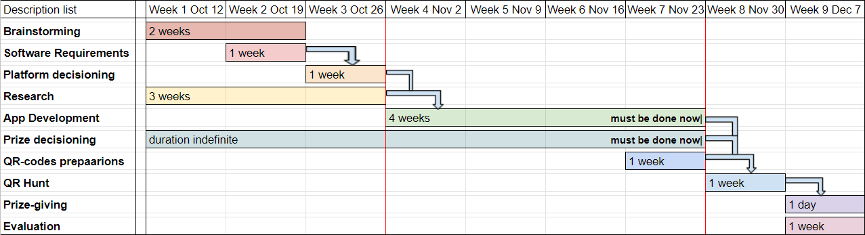

[Project Plan Graph](https://docs.google.com/spreadsheets/d/19V-kH2EuncAQKCcDCOFPFSP2b9gjl3NO04ppJEnY5E8/edit#gid=0)

Risks Plan